| **Test Name** | | Test validation of Worker, Error, & User Pages | | | |
| --- | --- | --- | --- | --- | --- |
| **Use Case Tested:** | | Validation of input into text fields on the above pages | | | |
| **Test Description:** | | User enters data into a text field on either Worker, Error, or User forms | | | |
| **Pre-conditions** | | Field is not a pick from list or radio button | | | |
| **Post-conditions** | | Input accepted if meeting criteria or error message appears indicating correct type of input | | | |
| **Notes:** | |  | | | |
| **Result (Pass/Fail/Warning/Incomplete)** | |  | | | |
|  | **TEST STEP** | | **EXPECTED TEST RESULTS** | P | F |
|  | Worker Form – Worker Id (numeric field only) | | Number accepted, any other character gives an error | X |  |
|  | Worker Form – Worker First Name (alpha, dash -) | | Alpha and dash (-) accepted, any other character gives an error | X |  |
|  | Worker Form – Worker Surname (alpha, dash -, apostrophe ‘) | | Alpha, dash (-), and apostrophe (‘) accepted, any other character gives an error | X |  |
|  | Worker Form – Worker Position (alpha) | | Alpha accepted, any other character gives an error | X |  |
|  | Error Form – Patient Id | | Alpha and Number accepted, any other character gives an error | X |  |
|  | Error Form – Patient First Name | | Alpha, dash (-), and apostrophe (‘) accepted, any other character gives an error | X |  |
|  | Error Form – Patient Surname | | Alpha, dash (-), and apostrophe (‘) accepted, any other character gives an error | X |  |
|  | Error Form – Medication | | Alpha and Number accepted, any other character gives an error | X |  |
|  | Error Form – Provider Number | | Alpha and Number accepted, any other character gives an error | X |  |
|  | Error Form – Physician First Name | | Alpha, dash (-), and apostrophe (‘) accepted, any other character gives an error | X |  |
|  | Error Form – Physician Surname | | Alpha, dash (-), and apostrophe (‘) accepted, any other character gives an error | X |  |
|  | User Form – Login | | Alpha accepted, any other character gives an error | X |  |
|  | User Form – Password | | Alpha and Number accepted, any other character gives an error | X |  |

|  |  |  |  |  |  |
| --- | --- | --- | --- | --- | --- |
| **Test Data Table** | | | | | |
|  | **1** | **2** | **3** | **4** | **5** |
| Test – Worker | See screenshots |  |  |  |  |
| Test – Error | See screenshots |  |  |  |  |
| Test – User | See screenshots |  |  |  |  |
|  |  |  |  |  |  |









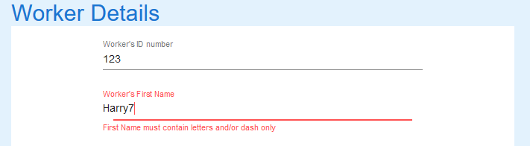









Various combinations tested, only sample screenshots provided

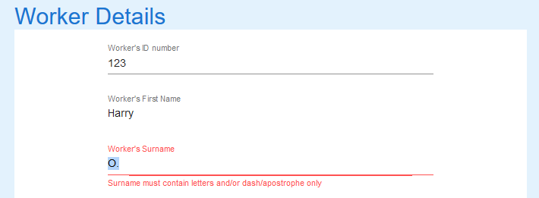









Various combinations tested, only sample screenshots provided

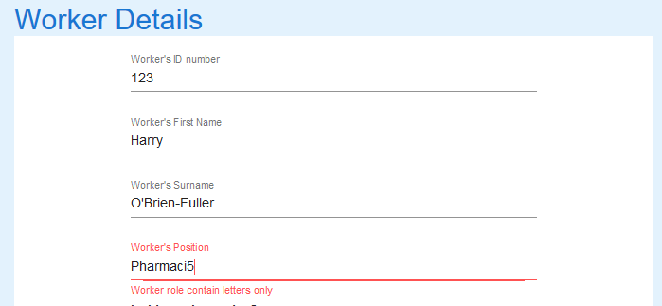







Various combinations tested, only sample screenshots provided

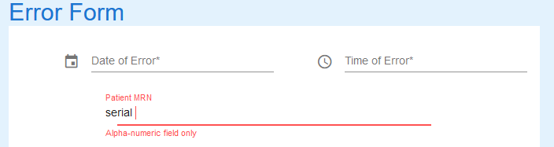











Various combinations tested, only sample screenshots provided













Various combinations tested, only sample screenshots provided















Various combinations tested, only sample screenshots provided















Various combinations tested, only sample screenshots provided















Various combinations tested, only sample screenshots provided













Various combinations tested, only sample screenshots provided



 





Various combinations tested, only sample screenshots provided

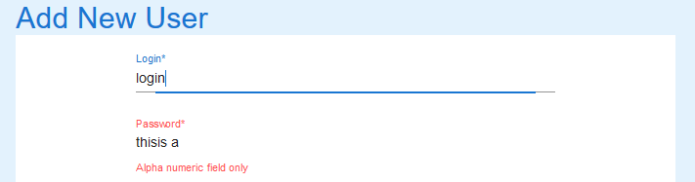

 







Various combinations tested, only sample screenshots provided